Lab Exercise Demonstration 3

COS30045 DATA VISUALIZATION

MOHAMED USAIDH ABDUL RAZZAQ

105017157@student.swin.edu.au

**Hosting**

<http://105017157.infinityfreeapp.com/index.html>

**GitHub**

https://github.com/Chakablaster/Main/tree/main/Lab

**Lab 5**

**Lab 5.1**

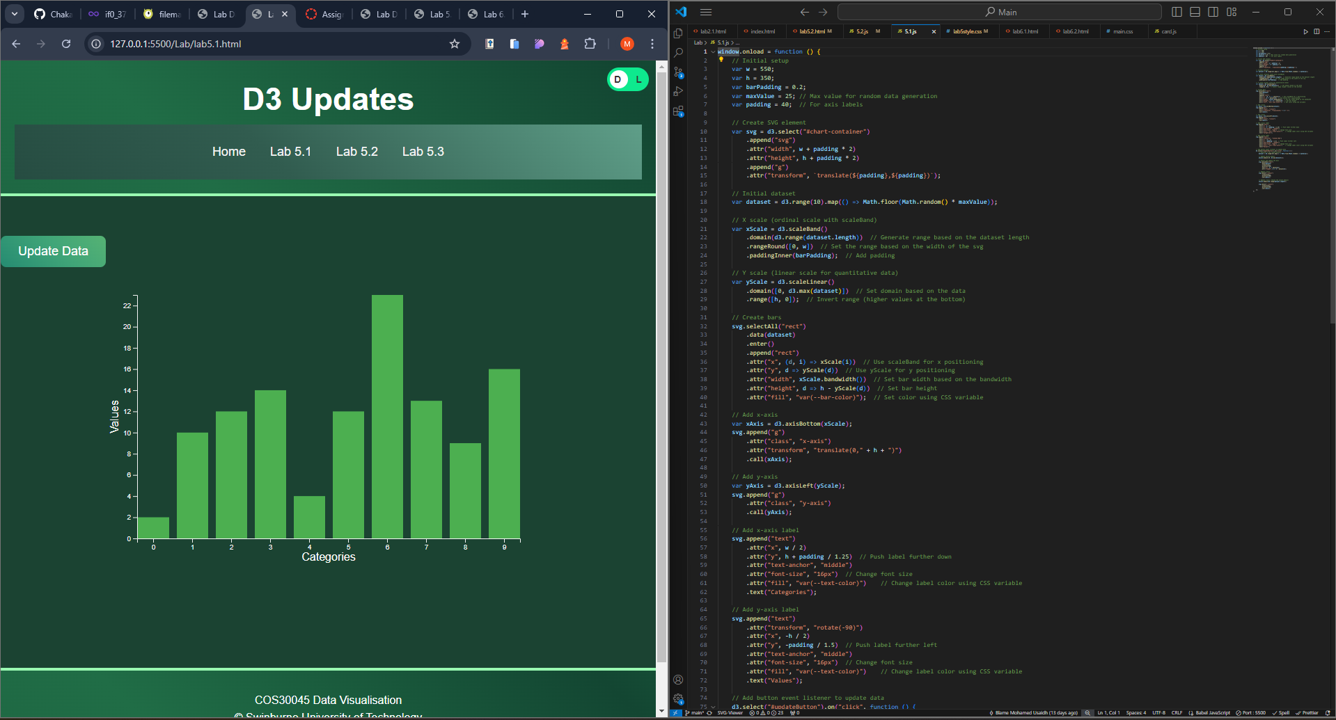

**Lab 5.2**

**Lab 5.3**

**Lab 6**

**Lab 6.1**

**Lab 6.2**

